GROUP 3 MAE
ASSIGNMENT 5

STUDENTS NAMES | REGISTRATION NUMBER
NAKAKANDE RACHEAL | BU/UP/2025/05767
DRICHI HENRY HANNINGTON | BU/UP/2025/4963
LYAKA AMELIA KIRABO | BU/UP/2025/05765
SSENYONJO TREVOR | BU/UP/2025/05769
ATWANZIRE ONANA VICTOR | BU/UP/2025/5176

NUMERICAL METHODS ASSIGNMENT
Solution of Non-linear Equations and ODEs using Newton, Secant and Runge-Kutta

1) Use Newton’s method to find the zeros of f(x)=1 - 3x + $\frac{1}{2}$ * (x e^x) accurate to five decimal places.

Function: f(x)=1-3x+0.5*x*exp(x)
Derivative: f'(x) = -3 + 0.5*exp(x)*(1+x)
Formula: $x_{n+1}$ = $x_{n}$ - $\frac{f(x)}{f'(x)}$
Iteration Table ($x_{n}$=0.35, Tol = ($1^{6}$):

MATLAB CODE – WHILE loop:
% Newton's Method using while loop
f = @(x) 1 - 3*x + 0.5*x*exp(x);
df = @(x) -3 + 0.5*exp(x). *(1 + x);

x0= 1; % initial guess
tol = 1e-5; % tolerance
maxIter = 100; % maximum iterations
iter = 0;

x = x0;
while iter < maxIter
x_new = x - f(x)/df(x);
if abs (x_new - x) < tol
break;
end
x = x_new;
iter = iter + 1;
end
fprintf ('Root ≈ %.5f after %d iterations\n', x_new, iter);

MATLAB CODE - FOR loop:
% Newton's Method using for loop
f = @(x) 1 - 3*x + 0.5*x*exp(x);
df = @(x) -3 + 0.5*exp(x). *(1 + x);
x0 = 1; % initial guess
tol = 1e-5; % tolerance
maxIter = 100; % maximum iterations

x = x0;
for iter = 1: maxIter
x_new = x - f(x)/df(x);
if abs (x_new - x) < tol
break;
end
x = x_new;
end

fprintf ('Root ≈ %.5f after %d iterations\n', x_new, iter);

pseudocode code:
Algorithm Newton Method
Input: initial guess x0, tolerance tol, max iterations N
Output: approximate root
Set x = x0
For k = 1 to N
Compute f(x) = 1 - 3x + 0.5*x*exp(x)
Compute f'(x) = -3 + 0.5*exp(x)*(1 + x)
x_new = x - f(x)/f'(x)
If |x_new - x| < tol
Return x_new
EndIf
Set x = x_new
EndFor
Return x_new
End
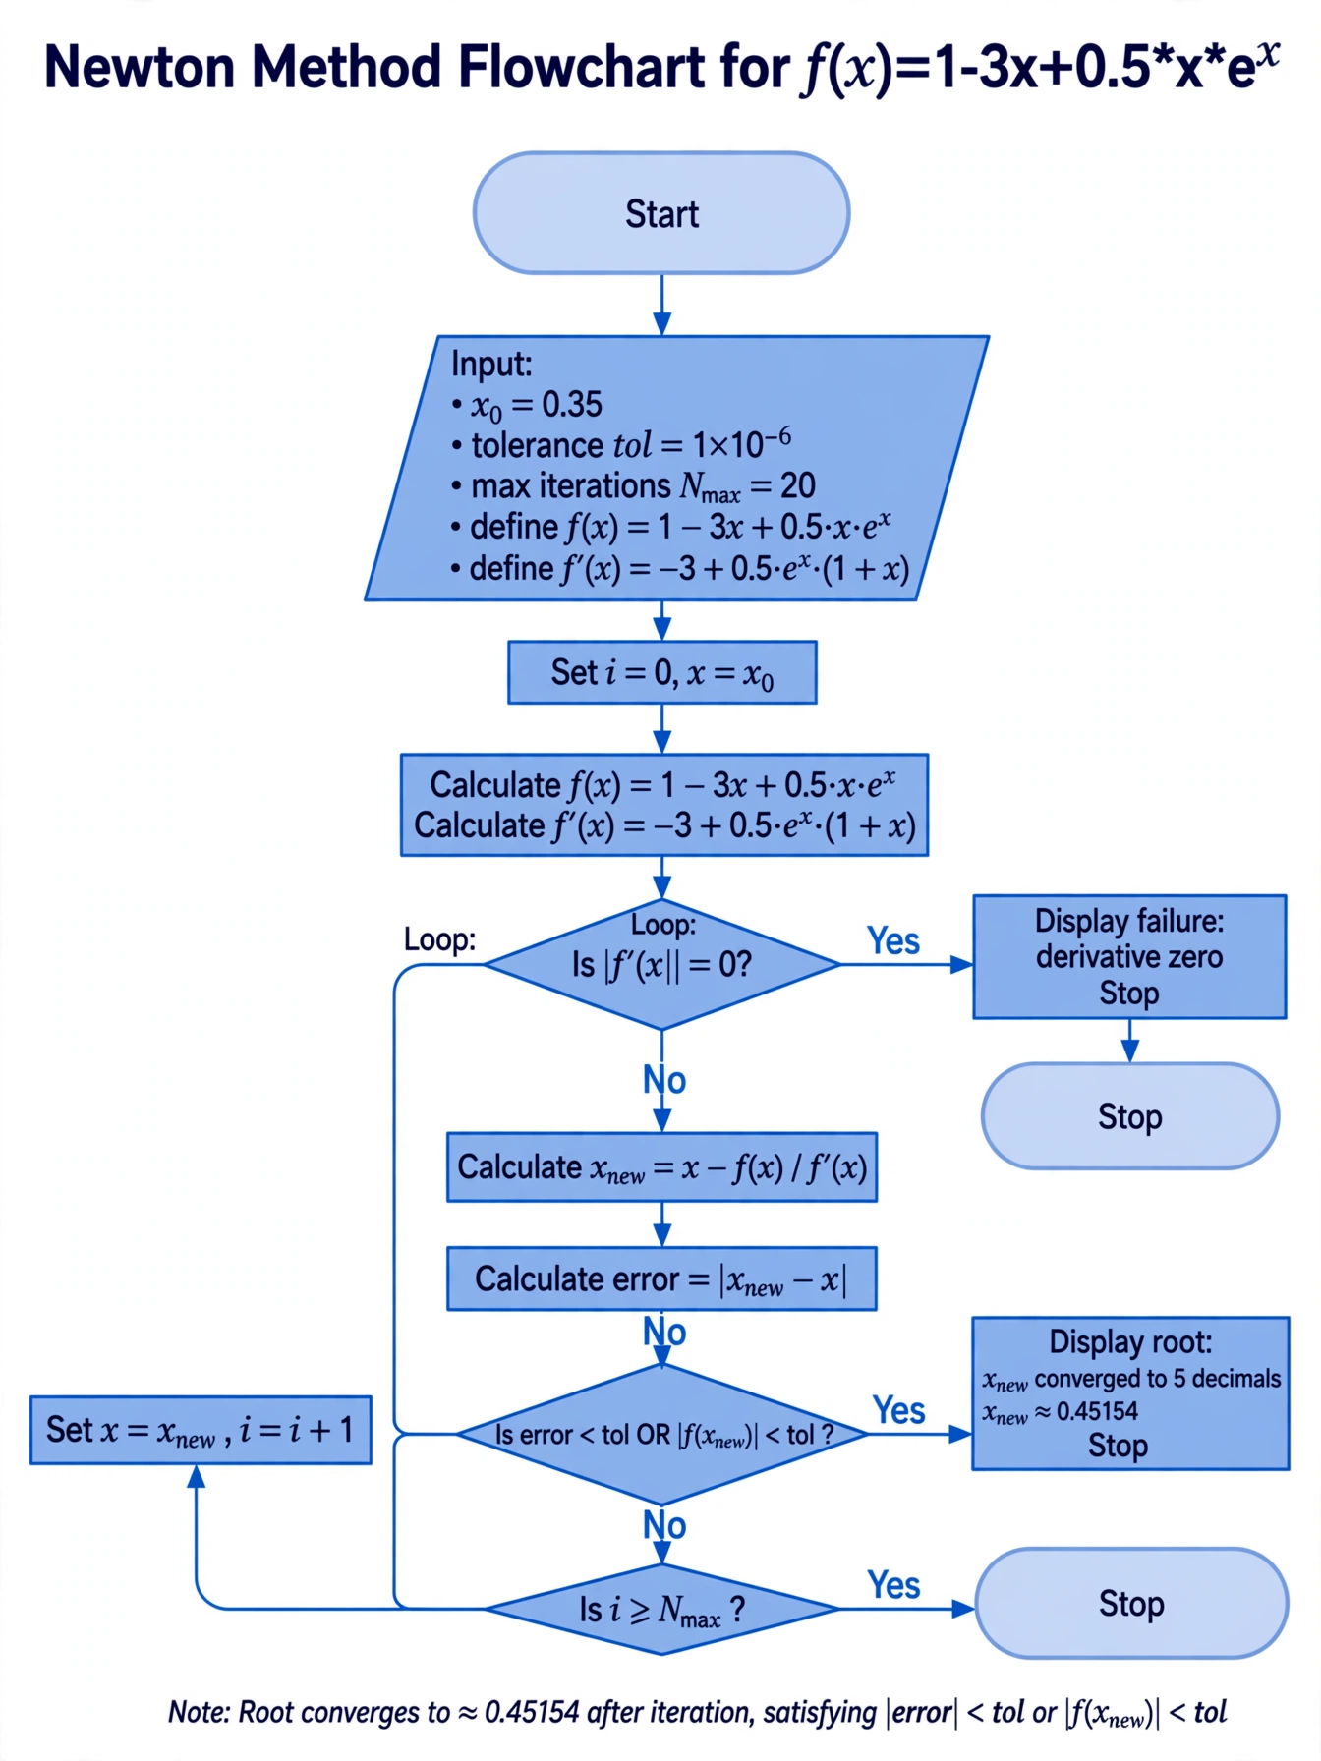

2) SECANT METHOD
Find the positive solution of f(x) = x – 2sinx = 0 by the secant method, starting with $x_{0}$= 2 and $x_{1}$= 1.9

MATLAB CODE - FOR LOOP
% Secant Method with for loop
f = @(x) x - 2*sin(x);
x0 = 2;
x1 = 1.9;
tol = 1e-5;
maxIter = 100;

for n = 1: maxIter
x2 = x1 - f(x1) *(x1 - x0)/(f(x1) - f(x0));
if abs (x2 - x1) < tol
break;
end
x0 = x1;
x1 = x2;
end

fprintf ('Root ≈ %.5f after %d iterations\n', x2, n);

MATLAB CODE - WHILE LOOP
% Secant Method with while loop
f = @(x) x - 2*sin(x);
x0 = 2;
x1 = 1.9;
tol = 1e-5;
maxIter = 100;
iter = 0;
while iter < maxIter
x2 = x1 - f(x1) *(x1 - x0)/(f(x1) - f(x0));
if abs (x2 - x1) < tol
break;
end
x0 = x1;
x1 = x2;
iter = iter + 1;
end
fprintf ('Root ≈ %.5f after %d iterations\n', x2, iter);

PSEUDOCODE
Input: initial guesses x0=2, x1=1.9, tolerance tol, max iterations N
Output: approximate root
Define f(x) = x - 2*sin(x)
For k = 1 to N
x2 = x1 - f(x1) *(x1 - x0)/(f(x1) - f(x0))
If |x2 - x1| < tol
Return x2
EndIf
x0 = x1
x1 = x2
EndFor
Return x2
EndAlgorithm
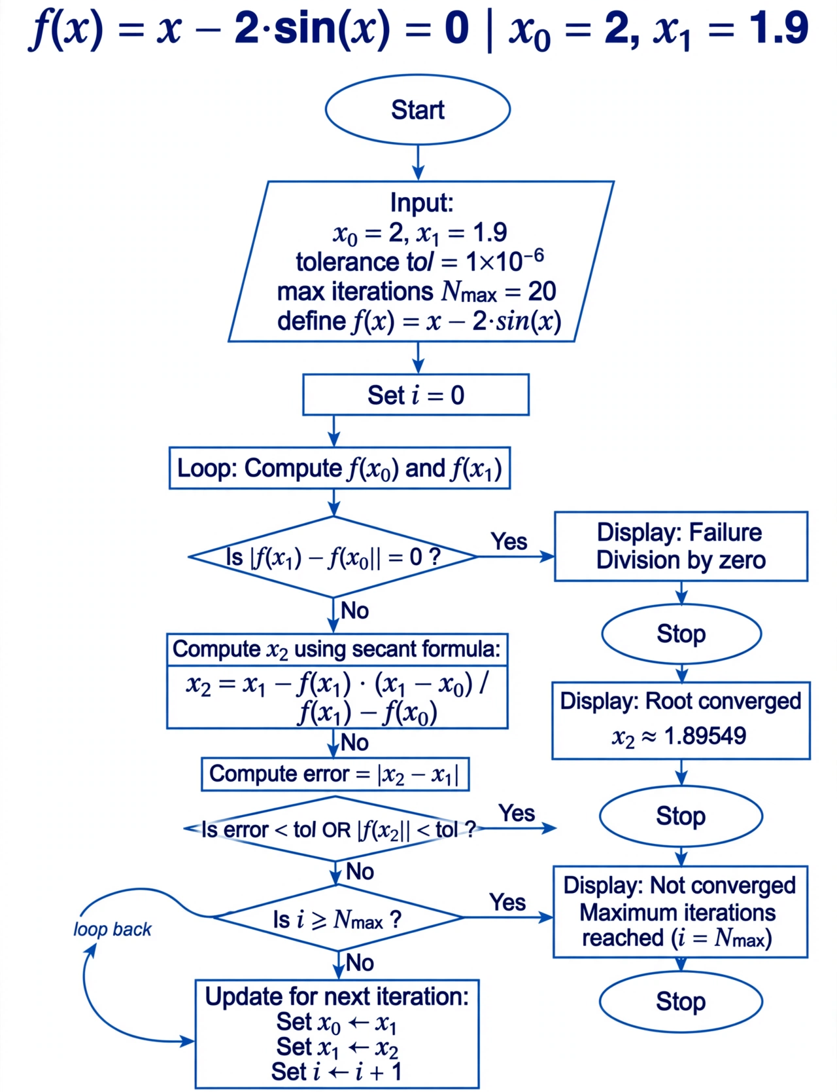

3) RUNGE-KUTTA METHOD
Use the fourth order Runge – Kutta algorithm with step size h = 0.2 to solve the initial value problem; $\frac{dy}{dx}$ + 2y =sin 3x with y (0) =1 in the interval 0 ≤ X ≤ 2.4.

MATLAB CODE USING FOR LOOP
% RK4 Method with for loop
f = @ (x, y) sin(3*x) - 2*y;

h = 0.2; % step size
x = 0:h:2.4; % interval
N = length(x);
y = zeros (1, N);
y (1) = 1; % initial condition

for n = 1: N-1
k1 = h * f(x(n), y(n));
k2 = h * f(x(n) + h/2, y(n) + k1/2);
k3 = h * f(x(n) + h/2, y(n) + k2/2);
k4 = h * f(x(n) + h, y(n) + k3);
y(n+1) = y(n) + (k1 + 2*k2 + 2*k3 + k4)/6;
end
disp (' x y');
disp ([x' y']);

MATLAB CODE USING WHILE LOOP
% RK4 Method with while loop
f = @(x,y) sin(3*x) - 2*y;

h = 0.2;
x = 0:h:2.4;
N = length(x);
y = zeros(1,N);
y(1) = 1;

n = 1;
while n < N
k1 = h * f(x(n), y(n));
k2 = h * f(x(n) + h/2, y(n) + k1/2);
k3 = h * f(x(n) + h/2, y(n) + k2/2);
k4 = h * f(x(n) + h, y(n) + k3);

y(n+1) = y(n) + (k1 + 2*k2 + 2*k3 + k4)/6;
n = n + 1;
end

disp (' x y');
disp ([x' y']);

Pseudocode
Algorithm RK4
Input: step size h, interval [0,2.4], initial condition y (0) =1
Output: approximate solution y(x)

Define f (x, y) = sin(3x) - 2y
Set x0 = 0, y0 = 1
Repeat until x reaches 2.4:
k1 = h * f (x, y)
k2 = h * f (x + h/2, y + k1/2)
k3 = h * f (x + h/2, y + k2/2)
k4 = h * f (x + h, y + k3)
y = y + (k1 + 2*k2 + 2*k3 + k4)/6
x = x + h
EndRepeat
Return values of y at each x
EndAlgorithm
